**AWS Overview**

**General information:**

Amazon Elastic Compute Cloud (Amazon **EC2**) is a web service that provides resizable computing capacity—literally, servers in Amazon's data centers—that you use to build and host your software systems. -> VMs in AWS

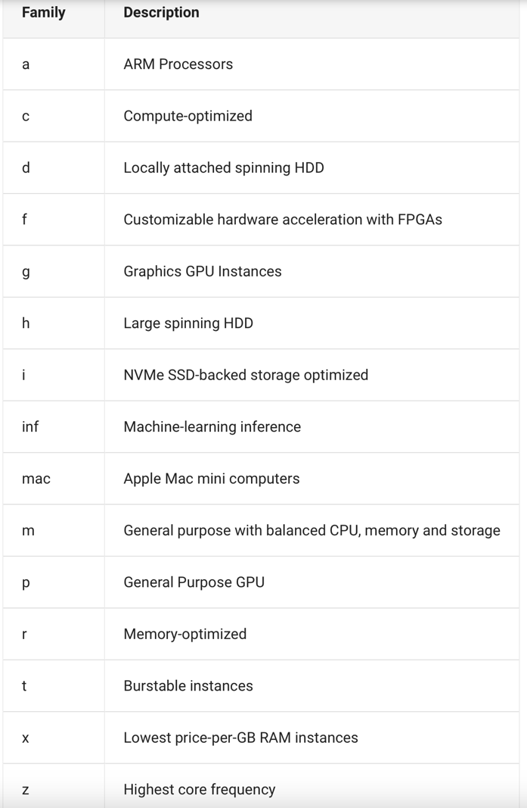Ein Bild, das Tisch enthält.
Instance family types on EC2:

Overview instance families: <https://aws.amazon.com/ec2/instance-types/>

Generational Upgrades:

EC2 instance types are grouped into families with multiple generations. For example a **m4.4xlarge** is of family **type m and generation 4**. The **next generation** for the same instance type would be **m5.4xlarge**. Typically, as cloud infrastructure providers release new families it's **cheaper and more performant to run the later generation instance types**. Upgrade instances from one generation to another can be a major area of cost savings. Generation upgrades usually result in between **5% and 10% cost savings** per generation and varies per family.

Amazon Simple Storage Service **(Amazon S3)** is an **object storage service** offering industry-leading scalability, data availability, security, and performance. Customers of all sizes and industries can store and protect any amount of data for virtually any use case, such as data lakes, cloud-native applications, and mobile apps. With cost-effective storage classes and easy-to-use management features, you can optimize costs, organize data, and configure fine-tuned access controls to meet specific business, organizational, and compliance requirements.

**Price models:**

* **On-demand**
* Pay for the instances that you use by the second or the hour, with a minimum of 60 seconds, with no long-term commitments or upfront payments
* On-Demand instances are recommended for:
  + Users that prefer the low cost and flexibility of Amazon EC2 without any upfront payment or long-term commitment
  + Applications with short-term, spiky, or unpredictable workloads that cannot be interrupted
  + Applications being developed or tested on Amazon EC2 for the first time
* **Spot instances**
  + Amazon EC2 Spot instances allow you to request spare Amazon EC2 computing capacity for up to 90% off the On-Demand prices
  + Spot instances are recommended for:
* Applications that have flexible start and end times
* Applications that are feasible only at very low compute prices
* Users with urgent computing needs for large amounts of additional capacity
* **Savings Plans**
  + Up to 66% discount
  + You can reduce your Amazon EC2 costs by making a commitment to a consistent amount of usage, in USD per hour, for a term of 1 or 3 years.
  + AWS recommends Savings Plans over RIs due to the higher flexibility
  + Applicable for EC2, Fargate and Lambda
* **Reserved Instances**
  + Up to 72% discount
  + You can reduce your Amazon EC2 costs by making a commitment to a specific instance configuration, including instance type and Region, for a term of 1 or 3 years.
  + AWS provides further discounts based on volume (500k – 4mio = 5%, 4mio – 10 mio = 10%, over = even more)
  + RI instance types:
* Standard RIs: These provide the most significant discount (up to 72% off On-Demand) and are best suited for steady-state usage.
* Convertible RIs: These provide a discount (up to 54% off On-Demand) and the capability to change the attributes of the RI as long as the exchange results in the creation of Reserved Instances of equal or greater value. Like Standard RIs, Convertible RIs are best suited for steady-state usage.
* Scheduled RIs: These are available to launch within the time windows you reserve. This option allows you to match your capacity reservation to a predictable recurring schedule that only requires a fraction of a day, a week, or a month.
  + RI attributes: When the attributes of the RI match the attributes of a used instance, the discount of the RI is applied and the capacity reservation is utilized. These attributes are:
* [Instance type](https://aws.amazon.com/ec2/instance-types/): Instance types comprise varying combinations of CPU, memory, storage, and networking capacity. For example, m4.2xlarge.
* Platform description: RIs can be purchased for Amazon EC2 instances running Linux/UNIX, SUSE Linux, Red Hat Enterprise Linux, Microsoft Windows Server, and Microsoft SQL Server platforms.
* Tenancy: If you are using instances with a default tenancy, purchase default tenancy Reserved Instances. If you are using dedicated instances, purchase Reserved Instances with a tenancy of dedicated.
* Availability Zone (optional): By selecting an Availability Zone, the RI you purchase will provide a capacity reservation and a discount for the use of instances in the selected Availability Zone. When an Availability Zone isn’t specified, the RI discount will apply to a running instance of any size (within the same family) in the region. As an example, let’s say you own an m4.2xlarge Linux/UNIX RI with default tenancy in US East (N.Virginia). Then this RI’s discounted rate can automatically apply to two m4.xlarge instances in us-east-1a or four m4.large instances in us-east-1b.
  + Reserved Instances Marketplace
    - Reserved Instance Marketplace allows other AWS customers to list their Standard RIs for sale. Third-party Standard RIs are no different from the Standard Reserved Instances purchased directly from AWS except they are often listed at lower prices and shorter terms.
* **Dedicated Hosts**
  + Amazon EC2 Dedicated Hosts allow you to use your eligible software licenses from vendors such as Microsoft and Oracle on Amazon EC2, so that you get the flexibility and cost effectiveness of using your own licenses, but with the resiliency, simplicity and elasticity of AWS.
  + An Amazon EC2 Dedicated Host is a physical server fully dedicated for your use, so you can help address corporate compliance requirements.
* Further price savings:
  + Free Tier: As part of the AWS Free Tier, you can get started with Amazon EC2 for free. This includes 750 hours of Linux and Windows t2.micro instances (t3.micro for the regions in which t2.micro is unavailable), each month for one year. To stay within the Free Tier, use only EC2 Micro instances.

**Links:**

On-demand prices: <https://aws.amazon.com/ec2/pricing/on-demand/>

Spot prices: <https://aws.amazon.com/ec2/spot/pricing/>

Savings Plans prices: <https://aws.amazon.com/savingsplans/compute-pricing/>

Reserved Instances prices: <https://aws.amazon.com/ec2/pricing/reserved-instances/pricing/>

Dedicated Hosts prices: <https://aws.amazon.com/ec2/dedicated-hosts/pricing/>